**Exp No. 1:** **Date: 02|03|2023**

**QUERIES IN SQL**

**1.1) Aim:** To write the queries for **Data Definition Language (DDL)** and **Data**

**Manipulation Language (DML)** Data definition language: CREATE, ALTER, DROP, TRUNCATE.

Data Manipulation Language: SELECT, INSERT, UPDATE, DELETE.

**1.2) SOFTWARE REQUIRED: MySQL, MySQL Workbench.**

**1.3) SQL QUERIES AND OUTPUT:**

**DDL:**

Q1) Write a query to create a Database for a company.

Query:



Output:



Q2) Write a query to create a table Employee with EmpID, EmpName, EmpAge, EmpAddress and EmpSalary.

Query:

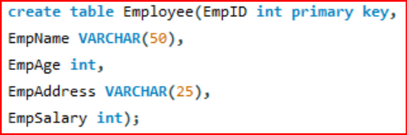

Output:



Q3) Write a query to add a new qualification (EmpQualification) in the EmpTable.

Query:



Output:

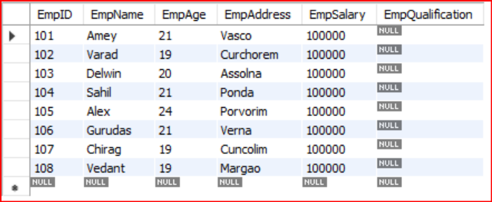



Q4) Write a query to alter the column EmpAddress size from 25 to 50.

Query:



Output:

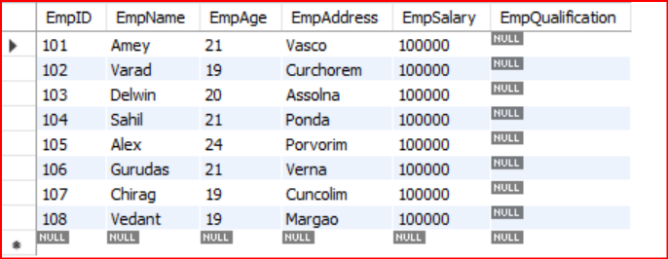



Q5) Write a query to truncate the record of the Employee.

Query:



Output:



Q6) Write a query to drop an existing table Employee.

Query:



Output:



DML:

Q1) Write a query to insert the records into Employee.

Query:

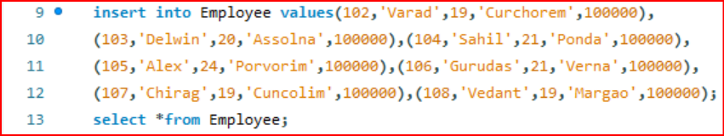

Output:

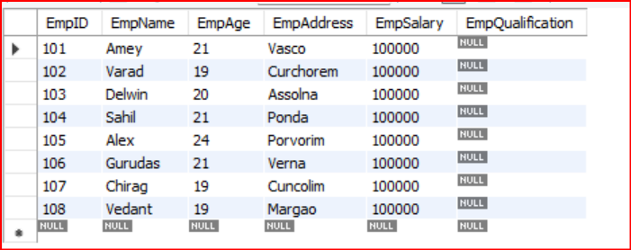



Q2) Write a query to display records of Employee.

Query:



Output:



Q3) Write a query to update the salary of the Employee.

Query:



Output:

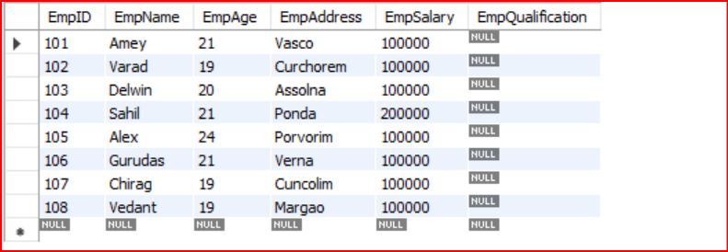



Q4) Write a query to delete a record using EmpID.

Query:



Output:

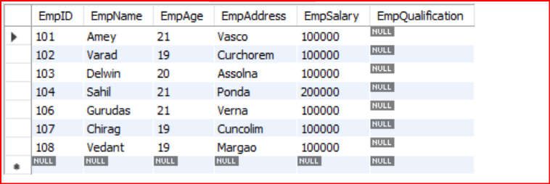



5)Write a query to fill in the qualification of the employees.

Query:



Output:

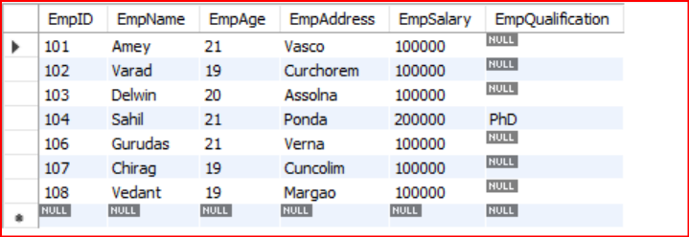



**1.4) CONCLUSION:** Queries for Data Manipulation Language (DML) and Data Definition Language (DDL) in SQL were implemented successfully.